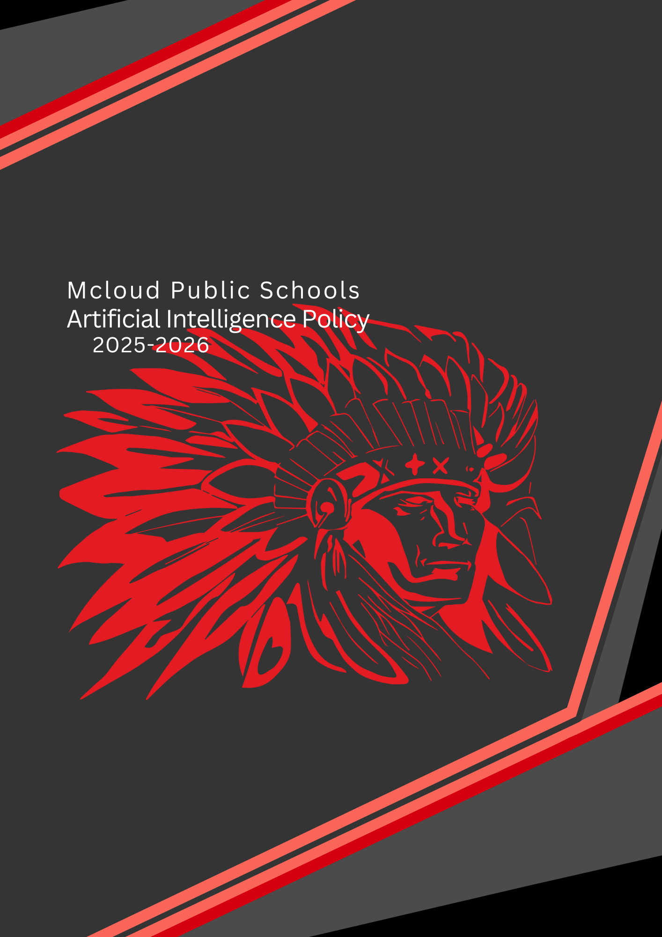

Overview
This Policy applies to all members of the Mcloud Public School District, including students, teachers, administrative staff, and other stakeholders within our school who may use Artificial Intelligence (AI) technologies. It particularly relates to generative AI, such as Large Language Models, but also includes AI tools employed to generate images, video, music, computer code etc., and all other manner of AI usage not stated within.
Rationale
AI resources are commonly accessible, readily available to teachers and students. These tools are also increasingly integrated into everyday digital resources employed by teachers and students. This policy is needed to ensure safe and acceptable use, aligned with Departmental requirements, school policy and both state and federal laws.
Purpose
The purpose of this policy is to provide guidelines for the Mcloud Public School District to adhere by the responsible use of AI, prioritizing privacy, security, and ethical considerations.
Our commitment
Mcloud Public Schools is committed to using AI in an ethical, transparent, and responsible manner. We acknowledge that AI has the potential to significantly enhance student learning and engagement. We also recognize the importance of protecting student safety, privacy, and academic integrity.
The importance of AI
The use of AI in Mcloud Public Schools aligns with our mission to provide a high-quality education that prepares our students for success in the 21st century. AI has the potential to support personalized learning and help teachers identify areas where students need extra support. They can also support research and writing activities and provide opportunities for students to develop skills related to critical thinking, problem-solving, and digital literacy.
This document serves as formal recognition at Mcloud Public Schools of the critical importance of AI in the future education and development of young people in our care. It observes our commitment to the ethical use of these tools and introduces their employment within Mcloud Public Schools.

Definitions
- Artificial Intelligence (AI): Computer systems or programs that simulate human intelligence, including natural language processing tools that can generate, summarize, or edit text. Examples include ChatGPT, Gemini, Grammarly, Copilot, and similar tools.
- AI-Generated Content: Any text, code, images, or other media produced by an AI tool.
- Academic Authenticity: The ethical completion of coursework. Examples include appropriately attributing text, pictures, tables, and graphs used in coursework to the creators and each student completing their own coursework, including not submitting work generated by artificial intelligence (AI) as the student’s own work.
- Academic Integrity: The commitment to and demonstration of honest and moral behavior in an academic setting, including producing original work and properly attributing sources.
- Misuse of AI: The use of AI tools in ways that compromise academic integrity, such as submitting AI-generated work without proper citation or using AI as a substitute for original thought and analysis.

Classroom Considerations, Transparency and Accountability
Teachers are responsible for explaining the limitations and opportunities afforded by AI to students, and the development of the necessary critical thinking skills to employ AI appropriately in support of their learning. It is a teacher’s responsibility to appropriately prepare students if they are asked to employ AI within a sequence of learning, to understand the bias, limitations and possible ethical considerations that may arise when using AI.
Acceptable Use
AI tools should be employed transparently, with clear guidelines to maintain academic integrity, particularly in assessments where their use should support but not replace, human judgment.
Teachers may use AI to support the critical evaluation of student work, but not as the main assessment method. Given AI tools are known to provide assessments of understanding in a way that can be biased or factually inaccurate, these resources must only be used in support of and not in place of assessment. It is expected that teachers will use a broad range of data and multiple forms of assessment to support student learning.
Where AI is employed by students, teachers may require students to identify the types of AI resources they drew on in the development of their work.
Where AI has been used by staff, particularly in program development, it should not be employed as a single point of reference, nor should it used without appropriate citation. Where ChatGPT for example has been used to support the development of content for a course, it should be acknowledged.
Permitted Uses of AI Tools:
- Students may use AI tools for the following purposes without citation:
    - Clarifying complex concepts and creating practice questions;
    - Translation and providing real-world examples;
    - Explanation of code, helping to debug errors, and/or suggestions on the structure code;
    - Correcting spelling, grammar, and punctuation;
    - Enhancing clarity, sentence structure, and fluency of language (e.g., Grammarly, Microsoft Editor);
    - Reviewing tone or style suggestions for improving readability; or
    - As indicated in the course/program-specific instructions, if any.
- Students may use AI tools with required citations when:
    - Generating or paraphrasing portions of content;
    - Summarizing sources or background information; or
    - Developing arguments, examples, or supporting details.
Prohibited Uses of AI Tools. AI tools may not be used in the following ways:
As a substitute for original analysis, interpretation, or argumentation;
  - To complete assessments, assignments, or discussions requiring personal reflection, moral reasoning, or experiential insight;
  - In assignments that involve the use of proprietary, confidential, or sensitive data;
  - Copying or pasting solutions into a submission without comprehension;
  - Submitting AI-written code as original work, unless specially indicated in instructions;
  - To simulate human interaction or generate responses for assignments requiring engagement with human subjects; and
  - As otherwise prohibited by course/program-specific instructions.

Responsibilities
The following individuals and groups are responsible for the implementation and maintenance of this guiding document:
  - School leadership: responsible for providing resources, guidance, and support for implementing these guidelines.
  - Teachers: responsible for implementing the guidelines in their classrooms, including providing instruction on the ethical and responsible use of AI.
  - Instructional Leaders: responsible for guiding teachers in the pursuit of best practice in the use of AI in classrooms and course development.
  - Administrative staff: responsible for ensuring that AI is used in compliance with the guidelines, including data privacy and security policies.
  - Students: responsible for using AI in an ethical and responsible manner, as outlined in the guidelines.
  - Parents/guardians: responsible for supporting their children's appropriate and ethical use of AI in compliance with these guidelines.
Decisions supported by AI tools will remain under the ultimate control of our educators and administrative team, ensuring human responsibility and accountability. We will establish procedures for monitoring AI use and managing its impact, providing opportunities for our community to question and challenge the use of these technologies.
Guidelines: review and approval
The use and impact of AI tools within our community will be actively and regularly monitored, with procedures in place to identify and manage emerging risks and opportunities.
This commitment includes an annual review of the Mcloud Public Schools AI Policy to ensure our AI practices remain aligned with the evolving educational landscape and technological advancements.

Created By:
Created Date:
Reviewed:
Approved By:
Approval Date:
Next Review Date:

